Entering Subject Summaries
- Login to Teacher Kiosk
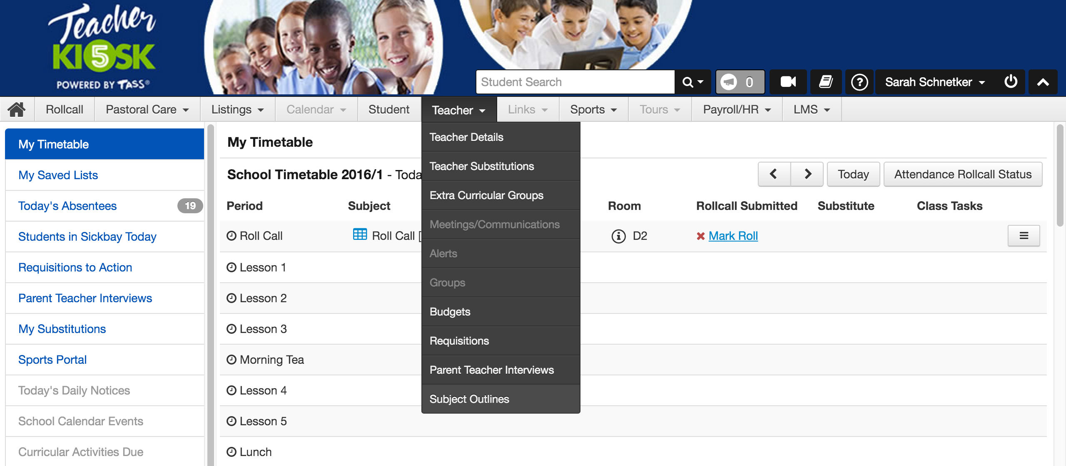
- Select Subject Outlines from the Teacher drop down menu

- On the right side, click the + sign

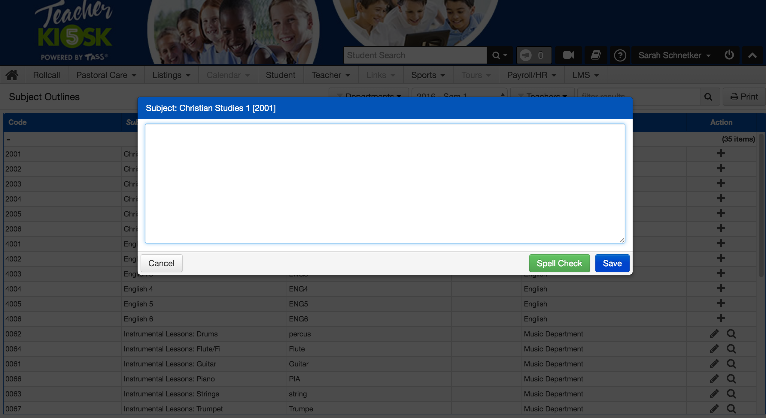
4. Enter your Subject Summary and click Save. Repeat for all subjects.

Entering Data for Student Reports

- Login to Teacher Kiosk and click the webBook link

- Once in webBook click Semester 1, 2016 and the following screen should appear:
- There are two ways that you can enter results: either via ‘Enter Results’ or ‘Grid Entry’. Select the appropriate choice from the subject you wish to enter results for. My advice would be to use ‘Grid Entry’ first to enter student results and then go into ‘Enter Results’ to put in your comments.

- When entering comments there is a spell check button and this program easily allows cut and pasting from word documents if you wish.

- When you are have finished entering your results and comments for that subject use the ‘View Printable Report’ button to edit & review.

Grid Entry Screen

Once you have selected the objectives you wish to enter results for the following screen will appear:

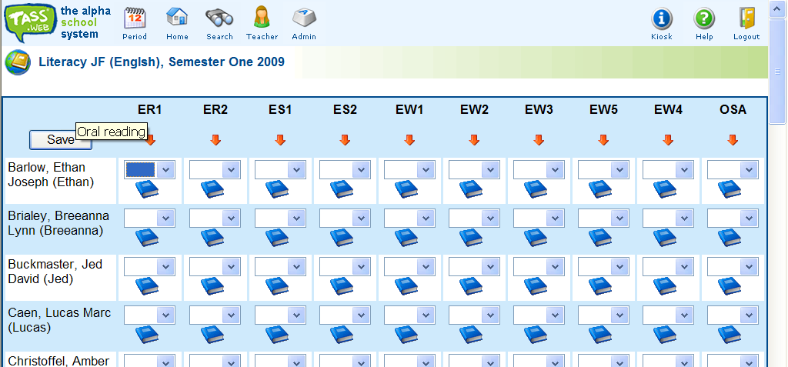

Things to note:
- Hovering over the objective code buttons at the top with your mouse will bring up a reminder of what these codes stand for
- The book symbols will bring up a separate window to guide you in result selection
- The red down arrows will fill down results from the top student’s result to make entering results easier
- Don’t forget to click save when you are finished!

